**SCREENSHOTS OF WEBSITE :**

LANDING PAGE :

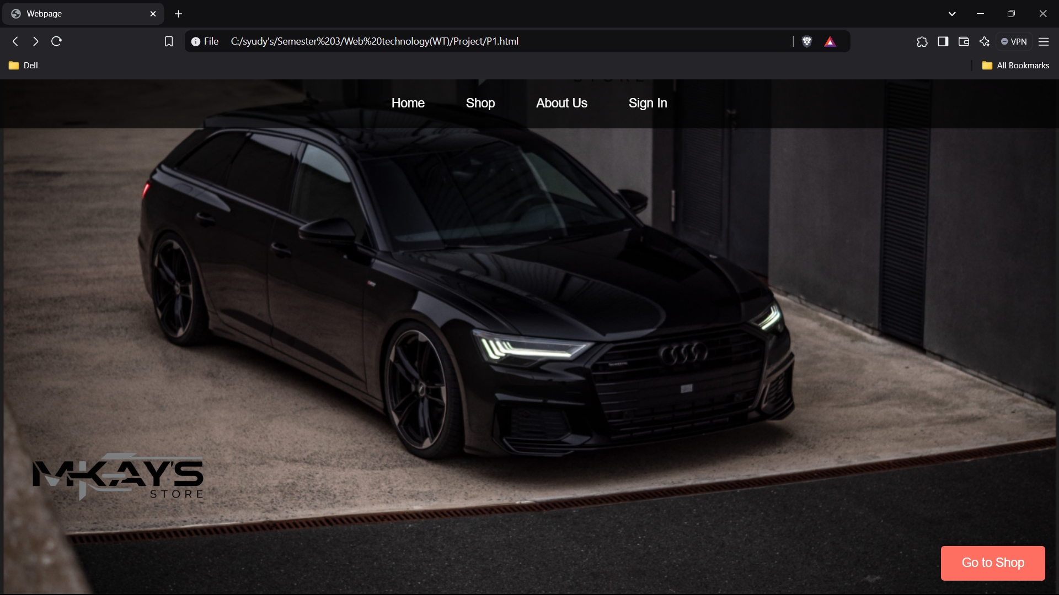

Product List PAGE :

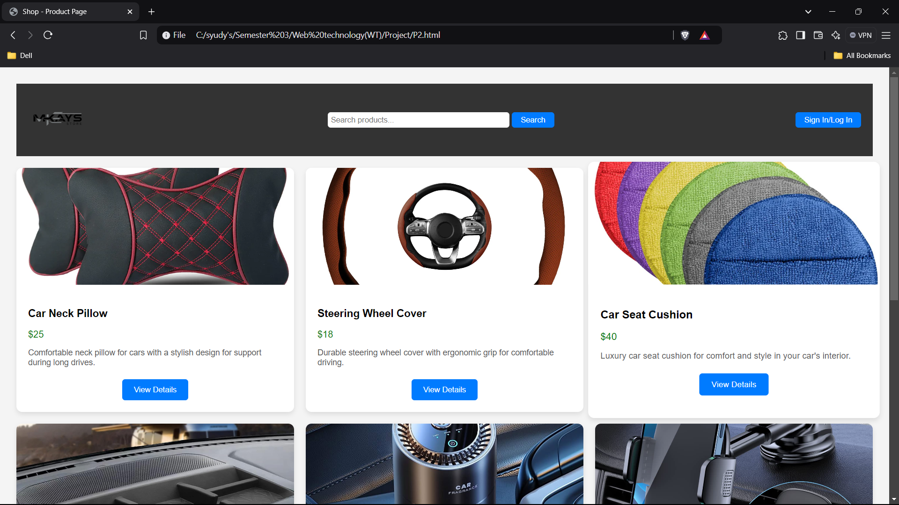

PRODUCTS DETAILS PAGE :

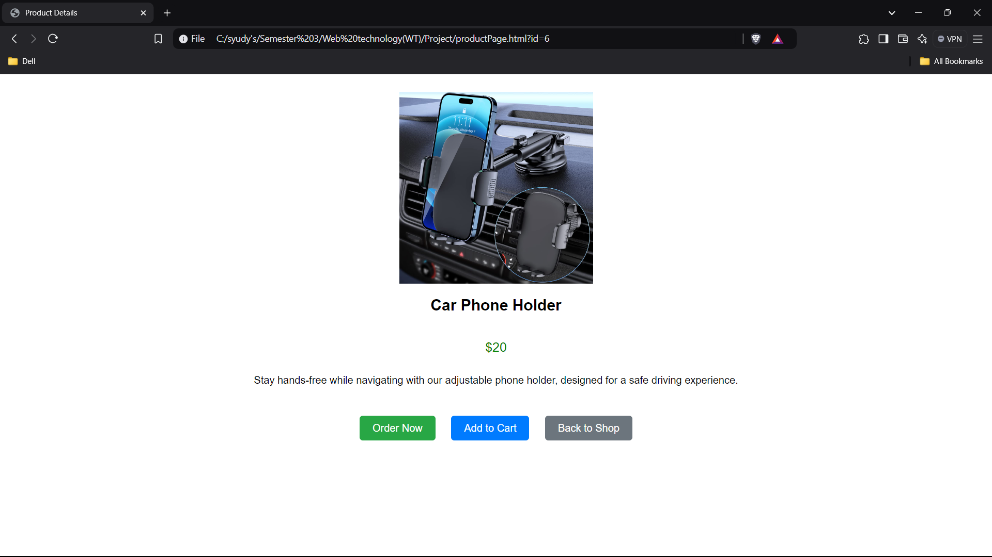

RESOURCES PAGE :

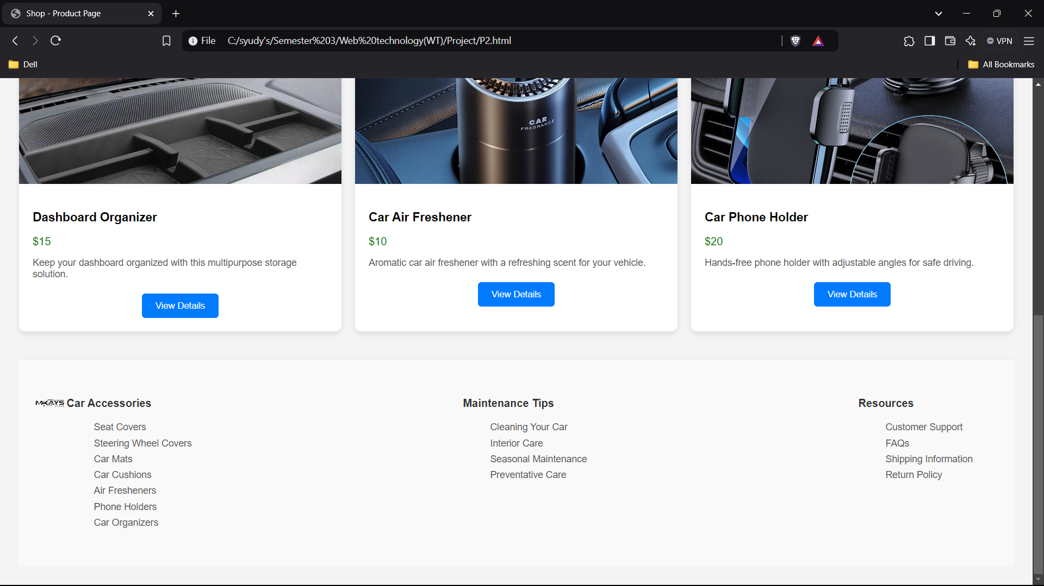

ABOUT US PAGE :

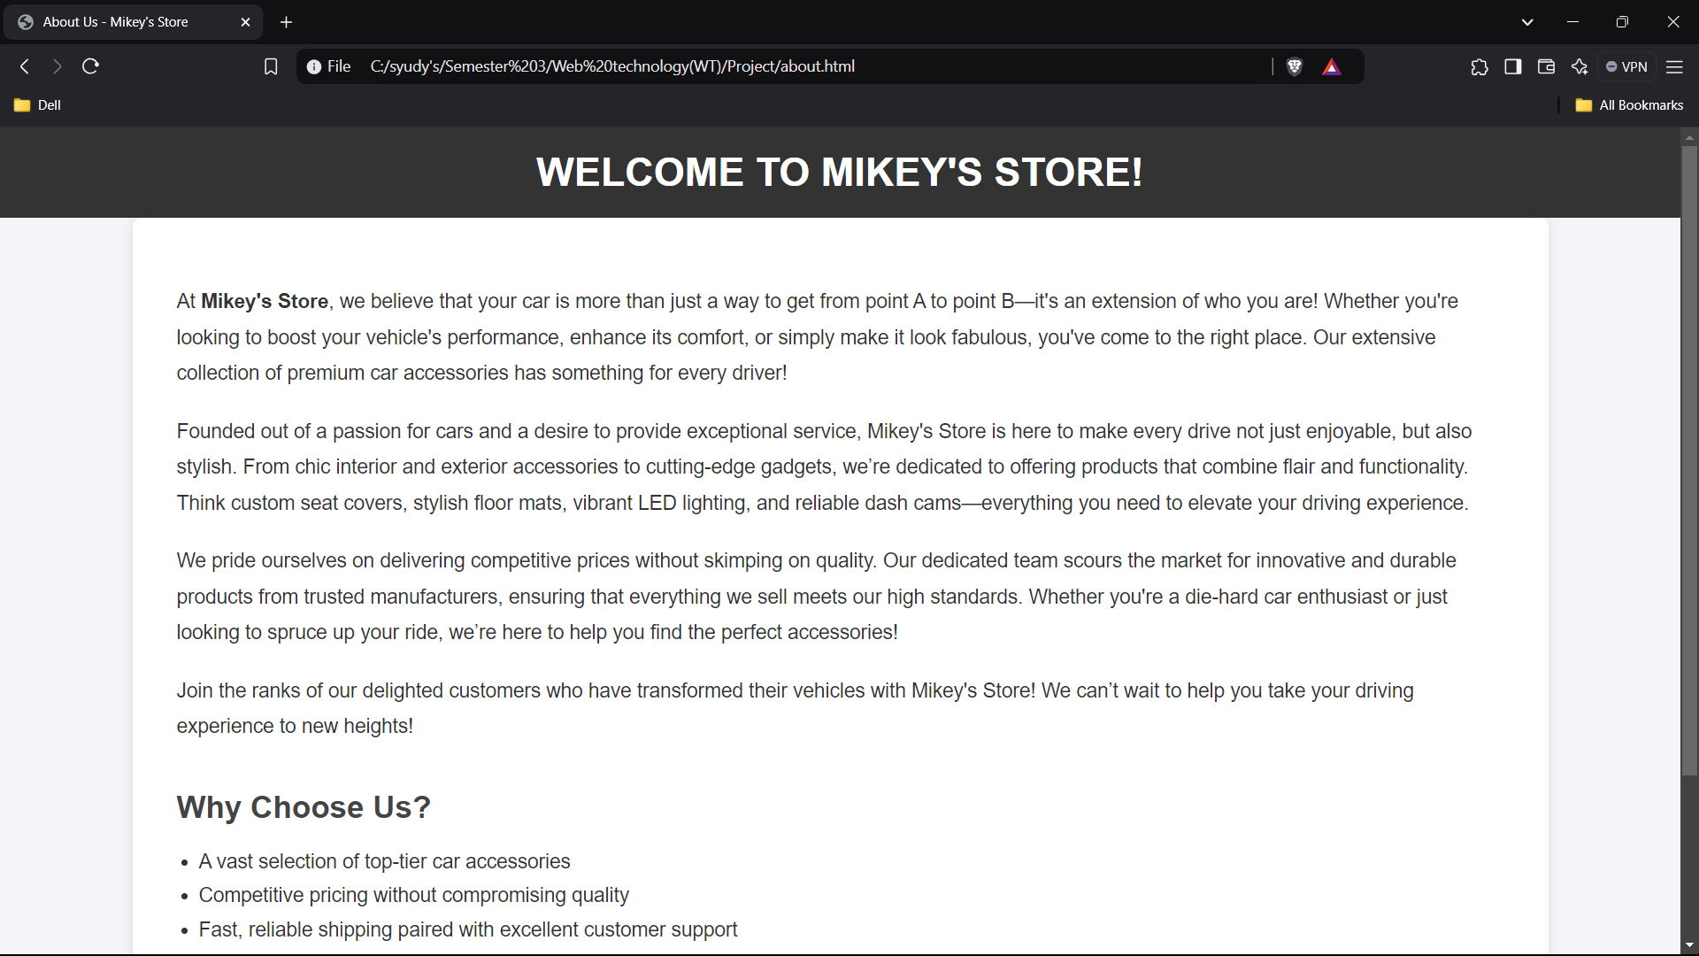

SIGNIN/SIGNUP PAGE :

